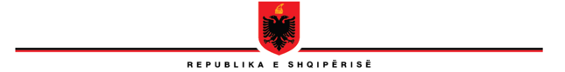

**REPUBLIC OF ALBANIA**

**THE SCHOOL OF MAGISTRATES**

**STEERING COUNCIL**

**No. 23/8 prot Tiranë, on 26.01.2023**

**DECISION**

**No.8, date 26.01.2023**

**ON THE NOMINATION OF THE RESPONSIBLE OF THE PROGRAM OF INITIAL FORMATION AND MEMBER OF THE STEERING COUNCIL**

Based on Articles 247, 248, 264, of law no. 115/2016, *on the organs of the management of the system of justice,* of the Internal Regulation of the School of Magistrates, approved by decision no.1, date 31.1.2017 (amended), as well as of the creation of the vacant position of the Responsible of the Program of Initial Formation, because of the resignation from duty of Mrs. Mariana Semini, as full – time lecturer, the Steering Council gathered on 26.01.2023, decided:

1. To nominate as Responsible of the Program of Initial Formation in the School of Magistrates, Mr. Sokol Berberi, releasing him from the position of the Responsible of the Program of Initial Formation.

1. Mr. Berberi, will continue to remain as member of the Steering Council of the School of Magistrates, in the status of the Responsible of the Program of Initial Formation.
2. This decision comes immediately into force!

**VICE-HEAD**

**OLSIAN ÇELA**