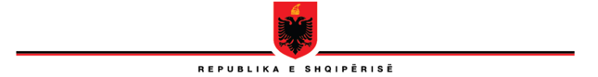

**REPUBLIC OF ALBANIA**

**THE SCHOOL OF MAGISTRATES**

**STEERING COUNCIL**

**DECISION**

**No. 25, date 17.05.2023**

**ON THE APPROVAL OF THE RANKING OF CANDIDATES WITH THE FINAL RESULTS NOTIFIES BY THE COMMISSION OF PROFESSIONAL TEST AND THE COMMISSION OF PSYCHOLOGICAL TEST AND OF MENTAL HEALTH**

Based on Articles 248, 266, and 247, letter (ë), of law no. 115/2016, *on the organs of the management of the system of justice,* of the Article 31 of law no. 96/2016, *on the status of judges and prosecutor in the Republic of Albania*, of the Article 53 of law no. 98/2016, *on the organization of the judicial power in the Republic of Albania*, of the Internal Regulation of the School of Magistrates, the Steering Council of the School of Magistrates, gathered on 17.5.2023, decided:

1. To approve the list of the ranking of candidates with the final results announced by the commission of professional test and the commission of psychological test and of mental health of the admission test for the academic year 2023-2024, according to the attached table, indivisible part of this decision.
2. This decision comes immediately into force!

**VICE-HEAD**

**OLSIAN ÇELA**