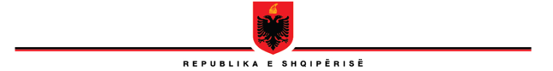

**REPUBLIC OF ALBANIA**

**THE SCHOOL OF MAGISTRATES**

**STEERING COUNCIL**

**No.210/3 prot. Tiranë, on 16.03.2023**

**DECISION**

**No.12, date 16.3.2023**

**ON THE APPROVAL OF THE DATES OF THE ADMISSION TEST IN THE PROGRAM OF INITIAL FORMATION FOR THE ACADEMIC YEAR 2023-2024**

In the application of the Article 30, point 1, law no. 96/2016, *on the status of judges and prosecutor in the Republic of Albania*, of law no. 115/2016, *on the organs of the management of the system of justice,* of the Internal Regulation of the School of Magistrates, The Steering Council of the School of Magistrates, gathered on 16.3.2023, decided:

1. To announce dates 19 April, 2023, (first phase) and 22 April,2023, (second phase), for the organization of the admission test in the Program of Initial Formation for the academic year 2023 – 2024.
2. The School of Magistrates is charged for the implementation of this decision.
3. This decision comes immediately into force!

**VICE-HEAD**

**OLSIAN ÇELA**